WHEN: 31st March – 2nd April, 2005
WHERE: Killarney
WHY: For the Men to get on fire for God
COST: €30 per person - €20 for under 12’s

Dear Fellow Men,

This is an invitation for you to come to our annual Men's Retreat that we have every year in Killarney, Co. Kerry. It is a spiritual retreat for men and boys like no other!
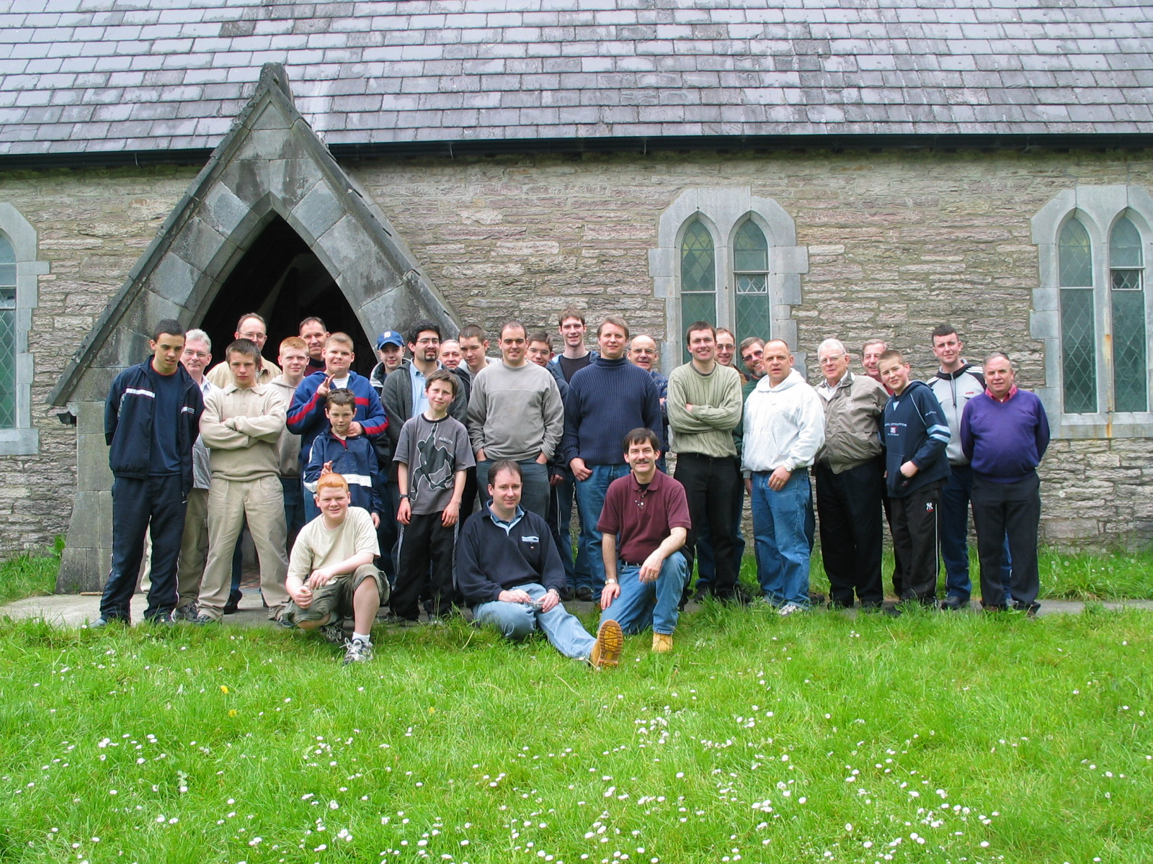
Here is a picture of just some of the men who came and were encouraged at last year’s meeting!

This year’s Men's Retreat will be held from Thursday evening (31st March) through to Saturday afternoon (2nd April). Last year we had 40 men, young men, and boys come and be changed by the practical preaching and godly fellowship that we all have when we get away from work, the bills, the TV, radio, school, the old friends and anything that just comes naturally between us and our spiritual growth!

The Theme of the retreat this year is the Study of the life of Timothy. Some of the items that will be preached on will include...
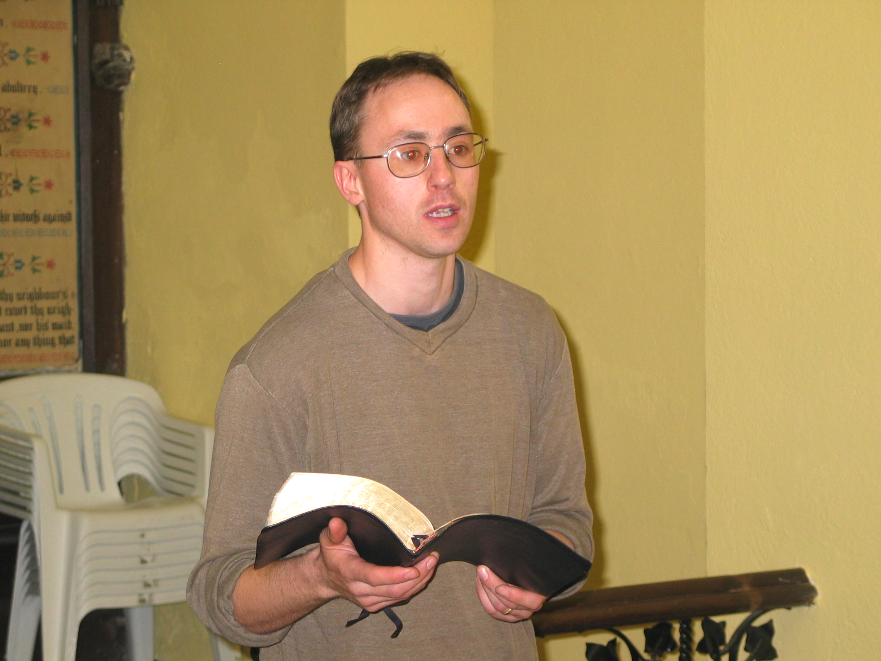
- The Need for Godly Homes (2Tim 1:5)
- How to have our Church Full of Timothy’s (2Tim 2:2)
- Never Be Ashamed (2Tim 1:8)
- Enduring Hardness (2Tim 2:1-4)
- The Importance of Right Doctrine (1Tim 4:16)
- Answering the Call to Preach (2Tim 3:1)
- And many other aspects of the life of this great man of God.

Various pastors will be preaching along the above thoughts.

The main Scripture verse that we all will be memorising will be 1 Timothy 4:12. It is in conjunction with our one and only desire to be “Faithful Men” for the Lord Jesus Christ – in our homes, on our jobs, in our churches, and ultimately, before our Lord Himself!

“Let no man despise thy youth;
but be thou an example of the believers,
in word, in conversation, in charity, in spirit, in faith, in purity.”
(1 Timothy 4:12)

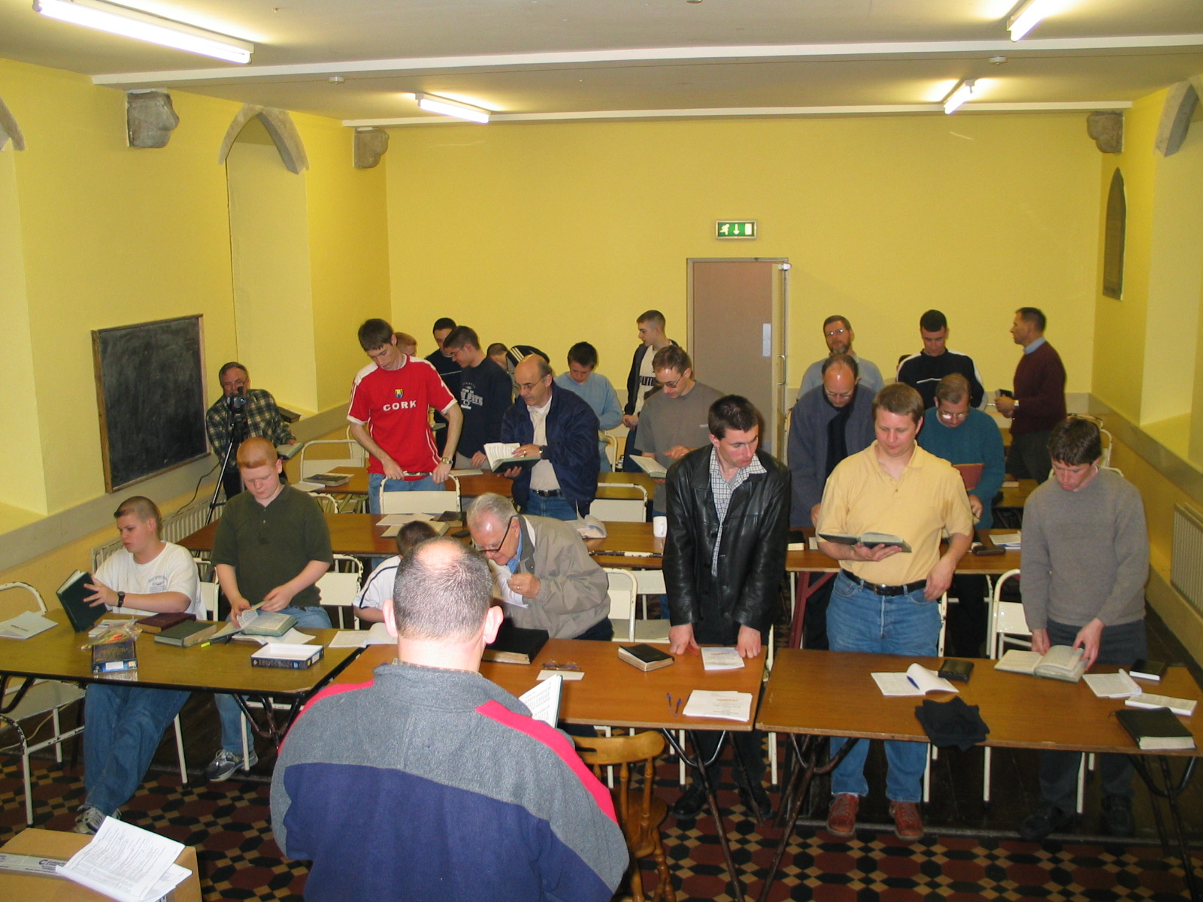
The purpose of the Men's Retreat is for the men in our various Bible believing Baptist churches to be under a special time of direct and clear preaching about living for God, serving God, and ultimately being Godly leaders in our churches here in Ireland. It is at events like this that men will hear God's call to preach, and get a greater burden to win souls!

Every man who comes will be blessed by the fellowship, great preaching and awesome singing!

Weather permitting, along with all the preaching, prayer times, fellowship, and lots of food, there will be mountain climbing, sports and hopefully a chance to witness for the Lord!
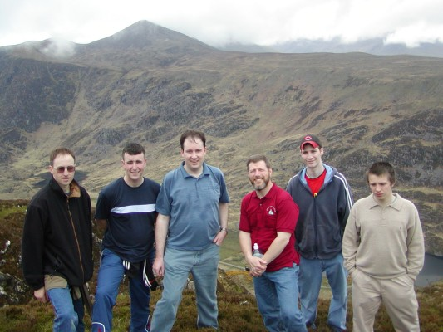
Teens, and even younger boys are encouraged to come as long as their father is with them, or as along as the pastor agrees to take responsibility for them.

Booking is first-come, first serve, so make your plans and let pastor Craig know as soon as you can whether you are coming and when you plan on arriving.

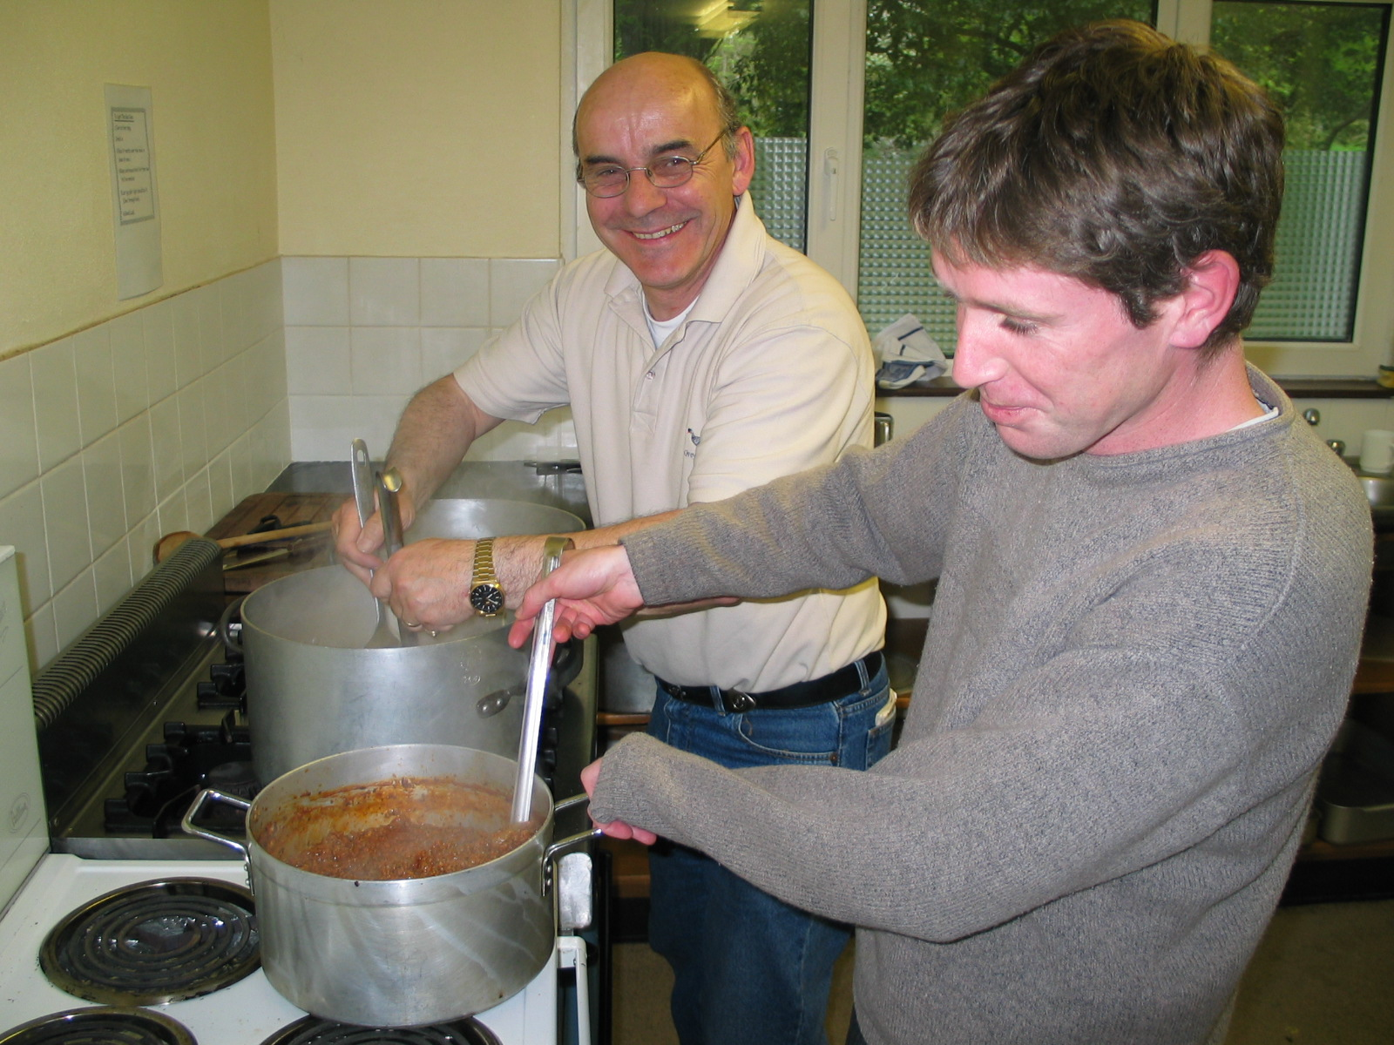
If you can come Thursday evening, and can stay all the way through till Saturday at Lunch, you will surely get a FULL CUP! But if you can only drive down on Friday, you still will be changed by the preaching!

Costs will be based on how many nights you can stay, and therefore how much FOOD each person eats. So, plan on about €30 per person (it may be more or less but it is a good number to hold to). That pays for the meals, and the hostel that we use for the meetings. Kids under 12 will just cost €20 each. If you can only come for one night, then take off €10.

From Cork, the village of Killarney is just one hour away. We have been doing this now for eight years, and it only gets better and better each time!

Please pray about being able to come, and let me know soon!

If you want to see photos of the many years we have had this preaching retreat, just go to www.biblebc.com/ChurchInfo/Blarney/Photo_files/MensRetreat/MensRetreatMainPage.htm
What To Bring
- Your Bible, pen or pencil for note-taking
- Pillow, sheets, and blankets, or sleeping bag
- Bath towel, washcloth, soap, shampoo
- Torch
- Hill-Walking shoes
- Any sports equipment that you can bring (including a baseball glove if you have it)
- Change of Clothes
- €30 each person

What to Expect
Easily expect to have a great time where you will be worn out, and yet very blessed by the preaching, the hiking, the eating, and the fellowship!

What To Do
Contact Pastor Craig Ledbetter and tell him you are coming, and how many with you, and when you plan on arriving.
If you have any questions, or need directions, just email, telephone, or write me back! But remember, this is on a first come first serve basis so LET ME KNOW SOON!

I can’t wait for the shout!

_____________________________
Pastor Craig Ledbetter
Bible Baptist Church, Ballincollig, Ireland
Tel: (021) 4875142 or, 087-276-6764
Email: craigled@iol.ie

*** Check us out on the WEB ***
www.biblebc.com

Directions
Directions to the Muckross Venture Centre in Killarney, which is a Hostel we rent out for the retreat (my mobile number if you get lost is 087-276-6764):
From Cork:
- Take the N22 (Macroom road) through Macroom, all the way into Killarney
- Once in Killarney, it will be easiest if you just ask for directions to the Muckross National Park.
- On your way to the Muckross National Park, just 1 mile from the entrance of the Park, will be a small shop on the left on a bend in the road. Just behind the shop will be what looks like a small church. That is the Muckross Venture Centre.

