Hey! You’re Invited!


An All-round Great Blast
for young people 13 to 18 years old!
Space is limited so come early!

Monday – Friday 14th – 18th August
7.00 – 9.00pm Every Evening
At the Ballincollig Gym Club

WHAT’S IT ALL ABOUT?
Helping Teens have a blast while getting to know the God who knows the answers to modern life and its troubles! We will look at issues like…

- Fixing Adult Problems in Young Lives
- Helping Young People Get Back On-Track
- Finding the God who’s been looking for them
- Fighting the Real Enemy for once
- Learning How to Forgive people all the way

So Many Incredible Games Like…
Titanic Tug-o-Wars
COST:
€5 per evening
Indoor Soccer Match
Deadly Dodge-Ball
20ft Ice Cream Sundae
And loads more stuff than you can imagine!

Come any day, but come
EVERY day for the best time ever!

Contact Information:
Craig Ledbetter  087-2766764
Sponsored by Bible Baptist Church Ballincollig
www.biblebc.com
Hey! You’re Invited!
An All-round Great Blast
for young people 13 to 18 years old!
Space is limited so come early!

Monday – Friday 14th – 18th August
7.00 – 9.00pm Every Evening
At the Ballincollig Gym Club

WHAT’S IT ALL ABOUT?
Helping Teens have a blast while getting to know the God who knows the answers to modern life and its troubles! We will look at issues like…

- Fixing Adult Problems in Young Lives
- Helping Young People Get Back On-Track
- Finding the God who’s been looking for them
- Fighting the Real Enemy for once
- Learning How to Forgive people all the way

So Many Incredible Games Like…
Titanic Tug-o-Wars
COST:
€5 per evening
Indoor Soccer Match
Deadly Dodge-Ball
20ft Ice Cream Sundae
And loads more stuff than you can imagine!

Come any day, but come
EVERY day for the best time ever!

Contact Information:
Craig Ledbetter  087-2766764
Sponsored by Bible Baptist Church Ballincollig
www.biblebc.com
Hey! You’re Invited!
An All-round Great Blast
for young people 13 to 18 years old!
Space is limited so come early!

Monday – Friday 14th – 18th August
7.00 – 9.00pm Every Evening
At the Ballincollig Gym Club

WHAT’S IT ALL ABOUT?
Helping Teens have a blast while getting to know the God who knows the answers to modern life and its troubles! We will look at issues like…

- Fixing Adult Problems in Young Lives
- Helping Young People Get Back On-Track
- Finding the God who’s been looking for them
- Fighting the Real Enemy for once
- Learning How to Forgive people all the way

So Many Incredible Games Like…
Titanic Tug-o-Wars
COST:
€5 per evening
Indoor Soccer Match
Deadly Dodge-Ball
20ft Ice Cream Sundae
And loads more stuff than you can imagine!

Come any day, but come
EVERY day for the best time ever!

Contact Information:
Craig Ledbetter  087-2766764
Sponsored by Bible Baptist Church Ballincollig
www.biblebc.com
WHERE’S IT ALL HAPPENING?
At the Ballincollig Gym Club
Next to Curves, in the
Link Road Business Park, Ballincollig
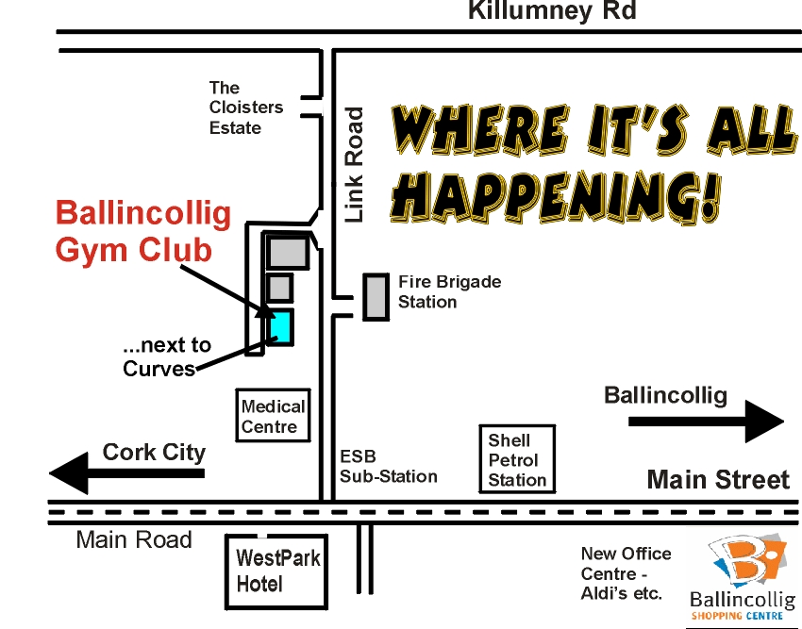

THEME:
“Search me O God and know my heart.” Psalm 139:23,24

WHAT’S IT COST?

WHO CAN COME?
EVERYONE 13-18yrs old
WHAT TO EXPECT
A Great Time - Great Food
Great Help - Great Fellowship
A Great Change

WHY COME?
Because everyone needs some solid answers and helps with life these days – don’t be shy about having fun while learning to follow Jesus and be what He designed you to be – the Best!

We reserve the right to refuse admission to troublesome teenagers - so be good!
WHERE’S IT ALL HAPPENING?
At the Ballincollig Gym Club
Next to Curves, in the
Link Road Business Park, Ballincollig

THEME:
“Search me O God and know my heart.” Psalm 139:23,24

WHAT’S IT COST?

WHO CAN COME?
EVERYONE 13-18yrs old
WHAT TO EXPECT
A Great Time - Great Food
Great Help - Great Fellowship
A Great Change

WHY COME?
Because everyone needs some solid answers and helps with life these days – don’t be shy about having fun while learning to follow Jesus and be what He designed you to be – the Best!

We reserve the right to refuse admission to troublesome teenagers - so be good!
WHERE’S IT ALL HAPPENING?
At the Ballincollig Gym Club
Next to Curves, in the
Link Road Business Park, Ballincollig

THEME:
“Search me O God and know my heart.” Psalm 139:23,24

WHAT’S IT COST?

WHO CAN COME?
EVERYONE 13-18yrs old
WHAT TO EXPECT
A Great Time - Great Food
Great Help - Great Fellowship
A Great Change

WHY COME?
Because everyone needs some solid answers and helps with life these days – don’t be shy about having fun while learning to follow Jesus and be what He designed you to be – the Best!

We reserve the right to refuse admission to troublesome teenagers - so be good!

